John Rene Lorelli

DataScience Foundations

Week 13

M13 Exercise Choropleth

Create a report with the following:

* 1. The entire R code used when creating the choropleth map in (1).

> library(ggplot2)

> library(maps)

> library(readr)

> milesdrive <- read_csv("milesdrive.csv")

Parsed with column specification:

cols(

State = col_character(),

VMT = col_double()

)

> View(milesdrive)

> library(readr)

> lifeexp <- read_csv("lifeexp.csv")

Parsed with column specification:

cols(

State = col_character(),

`Life Expectancy` = col_double()

)

> View(lifeexp)

> install.packages("mapdata")

> library(mapdata)

> usa<-map_data("usa")

> install.packages("ggplot2")

> states<-map_data("state")

> state_base<-ggplot(data=states, mapping = aes(x=long, y=lat, group=group))+coord_fixed(1.3)+geom_polygon(color="black", fill="yellow")

> a<-read.csv("milesdrive.csv")

> a$VMT<-as.numeric(as.character(a$VMT))

> names(states)[names(states)=="region"]<-"State"

> levels(a$State)<-tolower(levels(a$State))

> stco<-merge(states, a, by="State")

> eb1<-state_base + geom_polygon(data=stco, aes(fill=VMT), color="white")+geom_polygon(color="black", fill=NA)+coord_fixed(1.3)+theme_bw()+ggtitle("VMT in Different States")

> eb2<-eb1+scale_fill_gradient(low="blue", high="darkorange")

> eb2

* 1. Screenshot of the choropleth map created in (1).

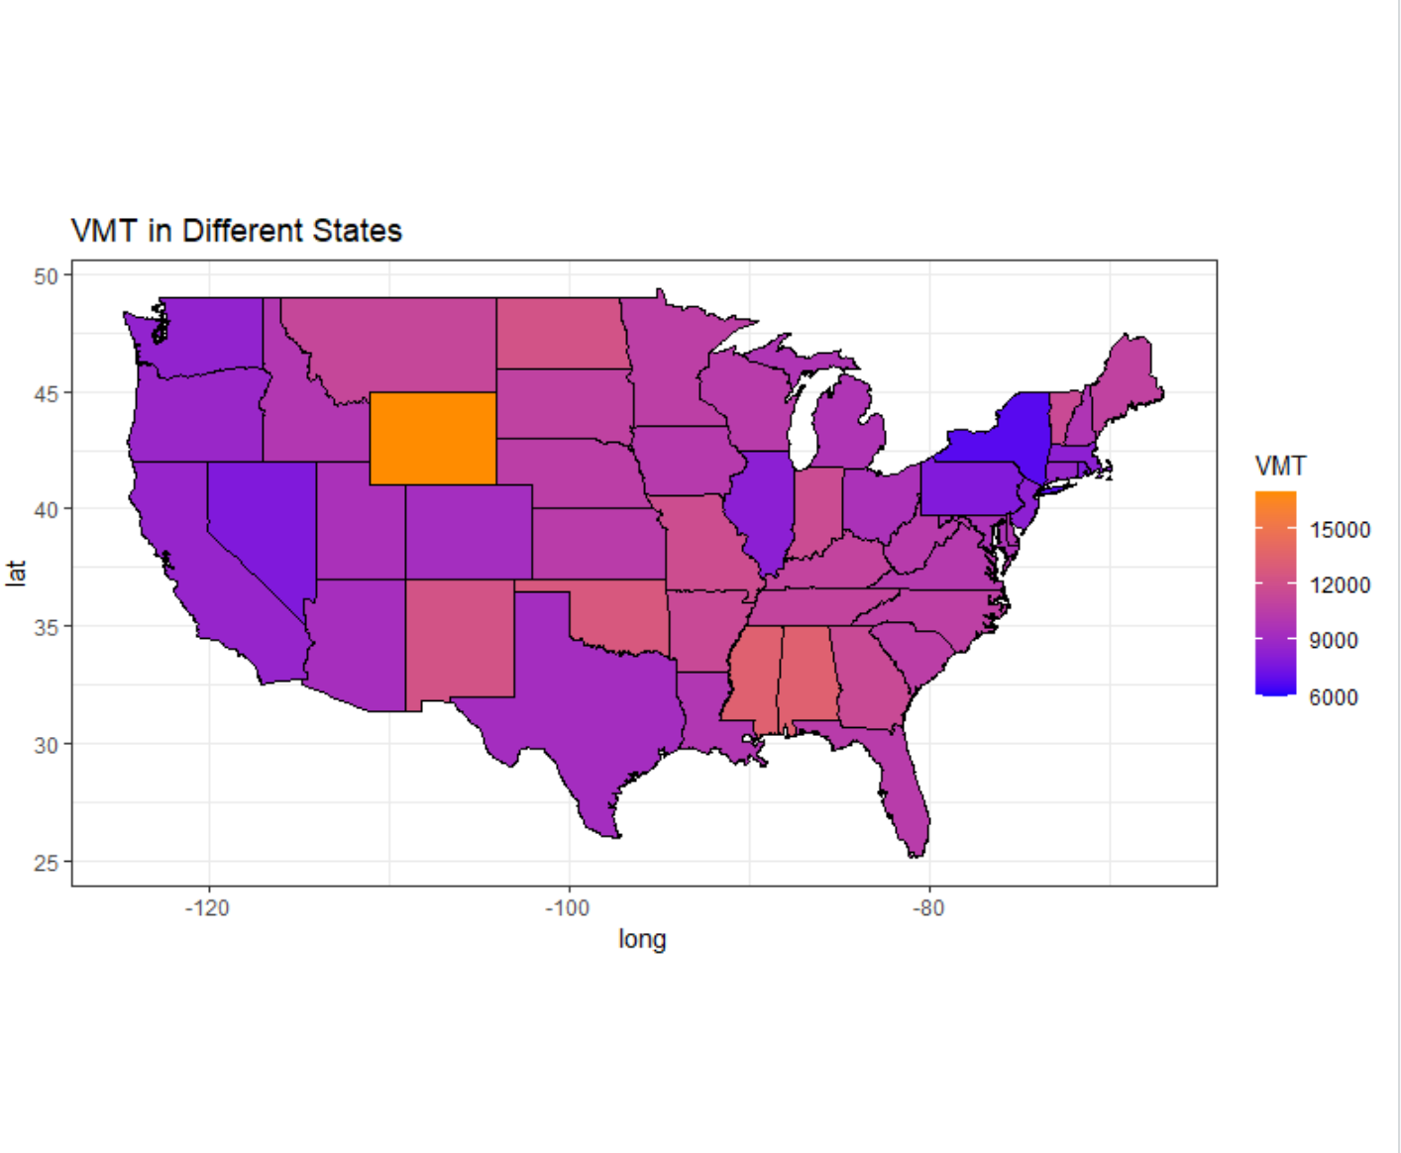

* 1. The entire R code used when creating the choropleth map in (2).

> b<-read.csv("lifeexp.csv")

> b$Life.Expectancy<-as.numeric(as.character(b$Life.Expectancy))

> levels(b$State)<-tolower(levels(b$State))

> stco1<-merge(states, b, by="State")

> eb3<-state_base + geom_polygon(data==stco1, aes(fill=Life.Expectancy), color="white")+geom_polygon(color="black", fill=NA)+coord_fixed(1.3)+theme_bw()+ggtitle("Life Expectancy in Different States")

Error in FUN(left, right) :

comparison (1) is possible only for atomic and list types

> eb3<-state_base + geom_polygon(data==stco1, aes(fill=lifeexp), color="white")+geom_polygon(color="black", fill=NA)+coord_fixed(1.3)+theme_bw()+ggtitle("Life Expectancy in Different States")

Error in FUN(left, right) :

comparison (1) is possible only for atomic and list types

> eb3<-state_base + geom_polygon(data==stco1, aes(fill=region), color="white")+geom_polygon(color="black", fill=NA)+coord_fixed(1.3)+theme_bw()+ggtitle("Life Expectancy in Different States")

Error in FUN(left, right) :

comparison (1) is possible only for atomic and list types

> head(lifeexp)

# A tibble: 6 x 2

State `Life Expectancy`

<chr> <dbl>

1 Hawaii 81.3

2 Minnesota 81.1

3 Connecticut 80.8

4 California 80.8

5 Massachusetts 80.5

6 New York 80.5

> eb3<-state_base + geom_polygon(data==stco1, aes(fill=Life Expectancy), color="white")+geom_polygon(color="black", fill=NA)+coord_fixed(1.3)+theme_bw()+ggtitle("Life Expectancy in Different States")

Error: unexpected symbol in "eb3<-state_base + geom_polygon(data==stco1, aes(fill=Life Expectancy"

> eb3<-state_base + geom_polygon(data==stco1, aes(fill=Life.Expectancy), color="white")+geom_polygon(color="black", fill=NA)+coord_fixed(1.3)+theme_bw()+ggtitle("Life Expectancy in Different States")

Error in FUN(left, right) :

comparison (1) is possible only for atomic and list types

> eb3<-state_base + geom_polygon(data==stco1, aes(fill=`Life Expectancy`), color="white")+geom_polygon(color="black", fill=NA)+coord_fixed(1.3)+theme_bw()+ggtitle("Life Expectancy in Different States")

Error in FUN(left, right) :

comparison (1) is possible only for atomic and list types

** I had a feeling the issue was with the aes fill but no matter what I put it gave an error. I tried multiple times as you can see and got know where with it. State definitions and variables were already defined from the first example so they are not listed.

* 1. Screenshot of the choropleth map created in (2).
  2. The entire R code used when creating the qualitative choropleth map in (3).

> library(ggplot2)

> library(maps)

> library(map_data)

Error in library(map_data) : there is no package called ‘map_data’

> usa<-map_data("usa")

> states<-map_data("state")

> counties<-map_data('county')

> state_base<-ggplot(data=states, mapping=aes(x=long, y=lat, group=group))+coord_fixed(1.3)+geom_polygon(color="black", fill="gray")+ggtitle("Life Expentacy Over 79 in USA")

> state_base

> p<-state_base + geom_polygon(data=counties, fill=NA, color="gray")+ geom_polygon(color="black", fill=NA)

> p

> l<-read.csv("lifeexp.csv")

> colnames(l)<-c("State", "LifeExp")

> l$LifeExp<-as.numeric(as.character(l$LifeExp))

> levels(l$State)<-tolower(levels(l$State))

> names(counties)[names(counties)=="region"]<-"State"

> countieslife<-merge(counties, l, by="State")

> biglife<-subset(countieslife, countieslife$LifeExp >= 79)

> bigb<-p+geom_point(inherit.aes=F, aes(x=long, y=lat), color ="blue",size= 0.5, data=biglife)

> bigb

* 1. Screenshot of the qualitative choropleth map created in (3).

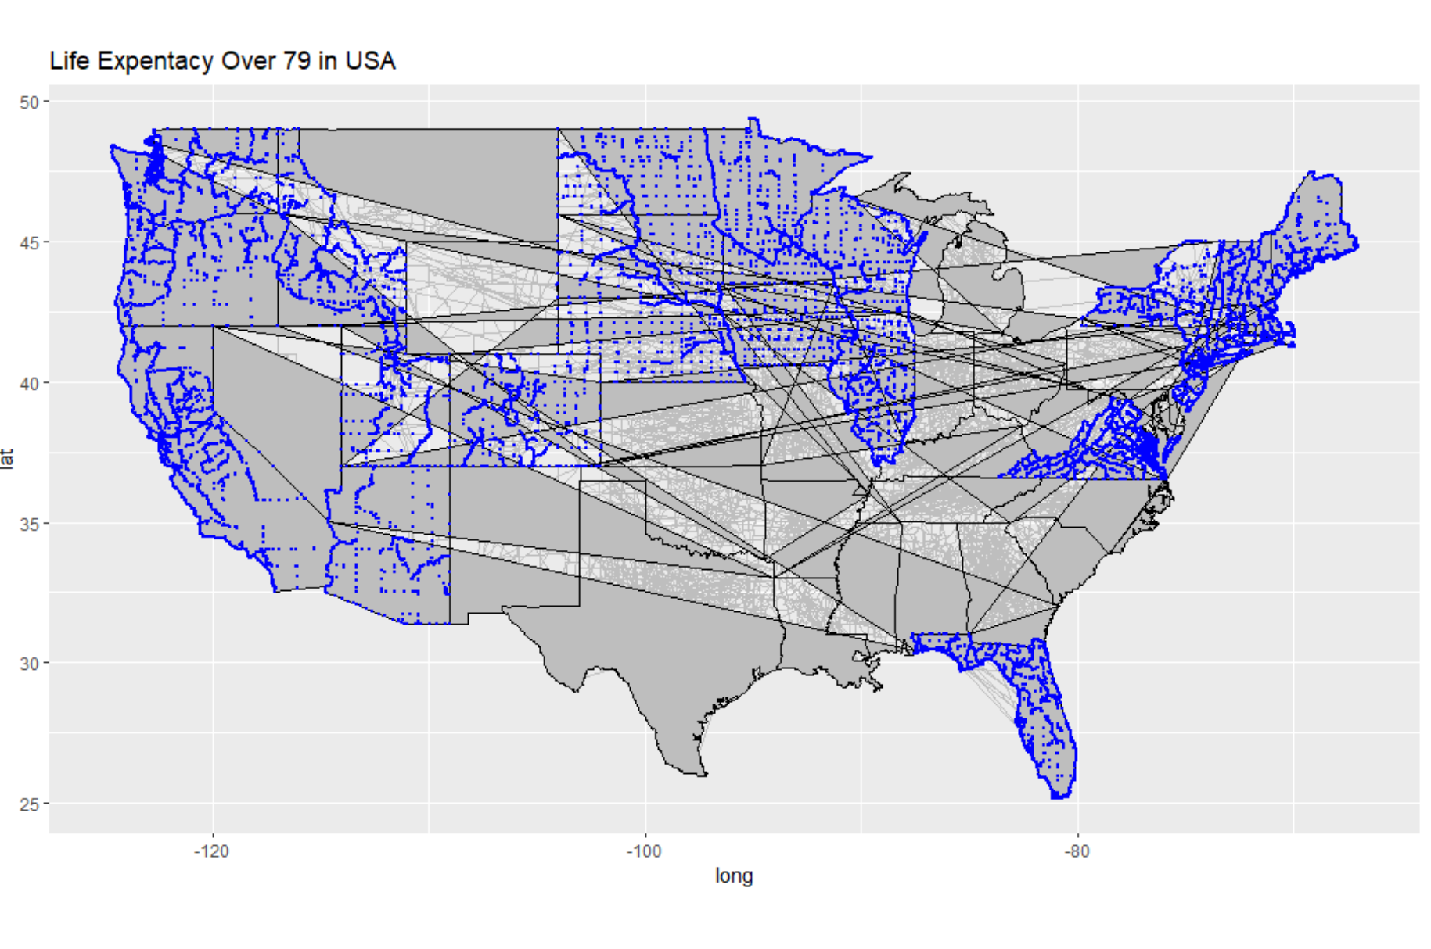

**I don't know what is wrong with my map. I followed the last video very closely and I don't know why it has those weird lines across the states.**